Austin Smothers

CISP 310

Assignment 8

; InSort.asm, a program which allows
; a user to input 10 numbers into
; an array, and performs and insertion
; sort on the array

; Austin Smothers
; CISP 310
; December 4, 2017

.586
.MODEL FLAT

INCLUDE io.h

.STACK 4096

.DATA
array DWORD 40 DUP (?), 0 ; the array (holds 10 elements)
string DWORD 4 DUP (?) ; used for input
maxVal DWORD 40 DUP(?), 0 ; used for math
arSize DWORD 8 DUP (?), 0 ; stores size of array
array2 DWORD 40 DUP (?), 0 ; a second array
fArPmt BYTE "Enter a number to store in the array", 0
result BYTE "Resulting Array:", 0

salut BYTE "Salutations", 0
hello BYTE "Hello!", 0
gBye BYTE "Goodbye!", 0

.CODE
_MainProc PROC
; populate a 10 element array with user input numbers
mov ecx, 0 ; initialize ecx
mov arSize, ecx ; initialize arSize

output salut, hello ; say hello

whileFill: cmp ecx, 10 ; loop while less than 10 elements
jae endwhileFill ; jump if ecx >= 10
call inSort ; call input and sort function
mov arSize, ecx ; store ecx (size of array) in arSize
jmp whileFill ; keep filling array
endwhileFill: mov arSize, ecx ; array must be filled

; time to output the filled and sorted array
mov ecx, 0 ; reset ecx
imul eax, 4 ; multiply arSize by 4
mov maxVal, eax ; store eax in maxVal
lea ebx, array ; store array's address in ebx
add ebx, maxVal ; start ebx at the top of the array size
lea edx, array2 ; store array 2's address
add edx, maxVal ; start edx at the top of the array size
whilePut: cmp ecx, arSize ; check if ecx has gotten to the size of array
jge endwhilePut ; jump if ecx >= size of array
dtoa [edx], [ebx] ; convert array1 to ASCII; store in array2
inc ecx ; increment ecx counter
sub ebx, 4 ; need to go down instead of up because dtoa
sub edx, 4 ; leaves leading 0's which overwrite data
jmp whilePut ; keep looping if we got here
endwhilePut: ; arrays must be fully converted
output result, array2 ; output array2 (ASCII array)
output salut, gbye ; say goodbye

; clean up
mov eax, 0 ; reset eax
mov ebx, 0 ; reset ebx
mov ecx, 0 ; reset ecx
mov edx, 0 ; reset edx

ret
_MainProc ENDP

; a function that will first determine where in array the user input belongs
; and then insert the user's input there, and move the array above that location
; "up by 1" to retain all data and keep the array sorted
inSort PROC
; reset any registers that this function decides to clobber
mov eax, 0 ; reset eax for input
mov ecx, 0 ; we clobber ecx for new counter
mov edx, 0 ; we will use edx for swapping
lea ebx, array ; reset ebx to point at element 1 of array

; get user input
input fArPmt, string, 2 ; ask user for a number to input
atod string ; convert string to a decimal

; find out where the user's input belongs
inSpot: cmp ecx, arSize ; check if ecx > arSize
jge endinSert ; jump if ecx >= arSize
cmp eax, [ebx] ; is user input < current element of ebx?
jl endinSpot ; jump if ebx is greater than eax
add ebx, 4 ; point to next element
inc ecx ; ecx stores which element we are on
jmp inSpot ; try again w/next element
endinSpot: ; [ebx] must be > eax

; at this point, ebx stores the address where eax must go
; and any element "above" ebx must be adjusted "up"
; to make room to store eax
inSert: cmp ecx, arSize ; check if we are at end of array
jge endinSert ; jump if ecx >= arSize (current size of array)
; didn't jump, must not be at end of array
xchg [ebx], eax ; swap [ebx] and eax
add ebx, 4 ; point to next element
inc ecx ; time to check next element
jmp inSert ; jump to inSort, we aren't done sorting
endinSert: ; we are at the last element of the array
mov [ebx], eax ; store eax in ebx
add ebx, 4 ; point to next element
inc ecx ; increment ecx

ret
inSort ENDP
END
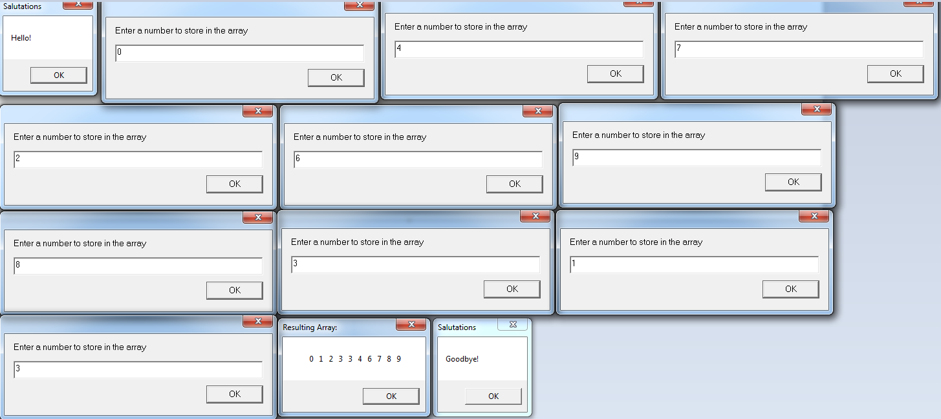

; BubSort.asm, a program which allows
; a user to input 10 numbers into
; an array, and performs a bubble
; sort on the array

; Austin Smothers
; CISP 310
; December 4, 2017

.586
.MODEL FLAT

INCLUDE io.h

.STACK 4096

.DATA
array DWORD 40 DUP (?), 0 ; array to store decimal input
array2 DWORD 40 DUP (?), 0 ; array to store ASCII input
string DWORD 4 DUP (?) ; used for input
maxVal DWORD 40 DUP(?), 0 ; used for math
arSize DWORD 8 DUP (?), 0 ; stores size of array
fArPmt BYTE "Enter a number to store in the array", 0
result BYTE "Resulting Array:", 0

salut BYTE "Salutations", 0
hello BYTE "Hello!", 0
gBye BYTE "Goodbye!", 0

.CODE
_MainProc PROC
; populate a 10 element array with user input numbers
mov ecx, 0 ; initialize ecx
mov arSize, ecx ; initialize arSize

output salut, hello ; say hello

whileFill: cmp ecx, 10 ; loop while less than 10 elements
jae endwhileFill ; jump if ecx >= 10
call inSertr ; call input and sort function
mov arSize, ecx ; store ecx (size of array) in arSize
jmp whileFill ; keep filling array
endwhileFill: mov arSize, ecx ; need this for insurance that arSize is last variable on stack

; sort the array
call bubSortr ; perform a bubble-sort on ebx

; time to output the filled and sorted array
mov ecx, 0 ; reset ecx
imul eax, 4 ; multiply arSize by 4: get size of array in eax
mov maxVal, eax ; store eax (result of imul) in maxVal
lea ebx, array ; store array's address in ebx
add ebx, maxVal ; start ebx at the top of the ebx array by adding maxVal to it
lea edx, array2 ; store array 2's address in edx
add edx, maxVal ; start edx at the top of the array size by adding maxVal to it

; need to start at the top of an array because the dtoa command leaves a trail of
; leading 0's this means that if start at the bottom of an array, dtoa will erase
; prior elements so we start at the top and convert the array from decimal to
; ASCII starting at the top and going down

whilePut: cmp ecx, arSize ; check if ecx has gotten to the size of array
jge endwhilePut ; jump if ecx >= size of array
dtoa [edx], [ebx] ; convert array1 to ASCII; store in array2
inc ecx ; increment ecx counter
sub ebx, 4 ; need to go down instead of up because dtoa
sub edx, 4 ; leaves leading 0's which overwrite data
jmp whilePut ; keep looping
endwhilePut: ; arrays must be fully converted
output result, array2 ; output array2 (ASCII array)
output salut, gbye ; say goodbye

; clean up
mov eax, 0 ; reset eax
mov ebx, 0 ; reset ebx
mov ecx, 0 ; reset ecx
mov edx, 0 ; reset edx

ret
_MainProc ENDP

; a function that accepts 10 integers from the user and stores
; them in the array at ebx
inSertr PROC
; reset any registers that this function decides to clobber
mov eax, 0 ; reset eax for input
mov ecx, 0 ; we clobber ecx for new counter
mov edx, 0
lea ebx, array ; reset ebx to point at element 1 of array

; get user input
inPutr: cmp ecx, 10 ; check if we have all 10 elements
jge endinPutr ; if ecx >= 10, we have all 10 elements, jump
input fArPmt, string, 2 ; ask user for a number to input
atod string ; convert string to a decimal, stored in eax
mov [ebx], eax ; put eax into the array
inc ecx ; increment ecx
add ebx, 4 ; point to next element
jmp inPutr ; loop until full
endinPutr: ; exit, we have all 10 elements

ret
inSertr ENDP
; a function which performs a bubble-sort on the ebx array
bubSortr PROC
mov ecx, 0 ; reset ecx for loop counter

; loop to track our passes through the array
lvl1: cmp ecx, 10 ; check if we're done sorting
jge endlvl1 ; if we are, jump to end of sort
lea ebx, array ; reset ebx address for bubble-sort
inc ecx ; track how many times we've sorted
push ecx ; store this loop's ecx
mov ecx, 0 ; reset ecx
; loop to track where we are in the array and make swaps
lvl2: cmp ecx, 9 ; check if we've passed through the array
jge endlvl2 ; jump if ecx >= 9 (we've made 9 passes)
mov eax, [ebx+4] ; store next element in eax
cmp [ebx], eax ; compare current element with the next one
jle skipSwap ; jump if element at ebx < element at ebx+4
; we didn't jump, current element is greater than next element: SWAP EM
xchg [ebx], eax ; swap current element with next element
skipSwap: ; where we jump if we don't swap
mov [ebx+4], eax ; put the current element (eax) in next element
inc ecx ; increment ecx
add ebx, 4 ; point to next element
jmp lvl2 ; keep looping, we aren't done sorting yet
endlvl2: ; we've passed completely thru the array
pop ecx ; get the old ecx counter back
jmp lvl1 ; keep looping, we aren't done sorting yet
endlvl1: ; done sorting

ret
bubSortr ENDP
END
